**SNOWFLAKE ASSIGNMENT**

(Sonam Kumari,TAS-204)

1. Create roles as per the below-mentioned hierarchy. Accountadmin already exists in Snowflake.

CREATE ROLE Admin;

GRANT ROLE Admin TO ROLE Accountadmin;

CREATE ROLE Developer;

GRANT ROLE Developer TO ROLE Admin;

CREATE ROLE PII;

GRANT ROLE PII TO ROLE Accountadmin;

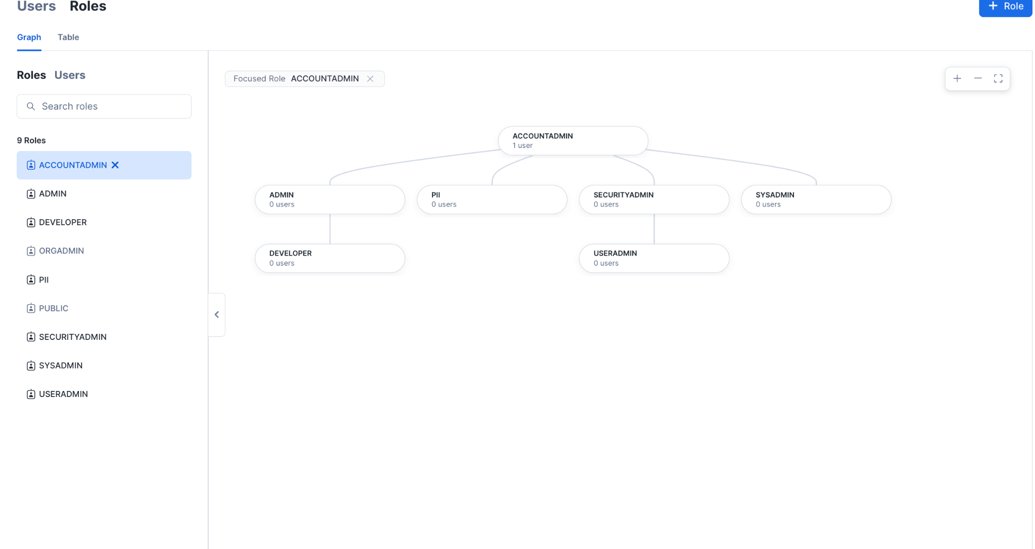

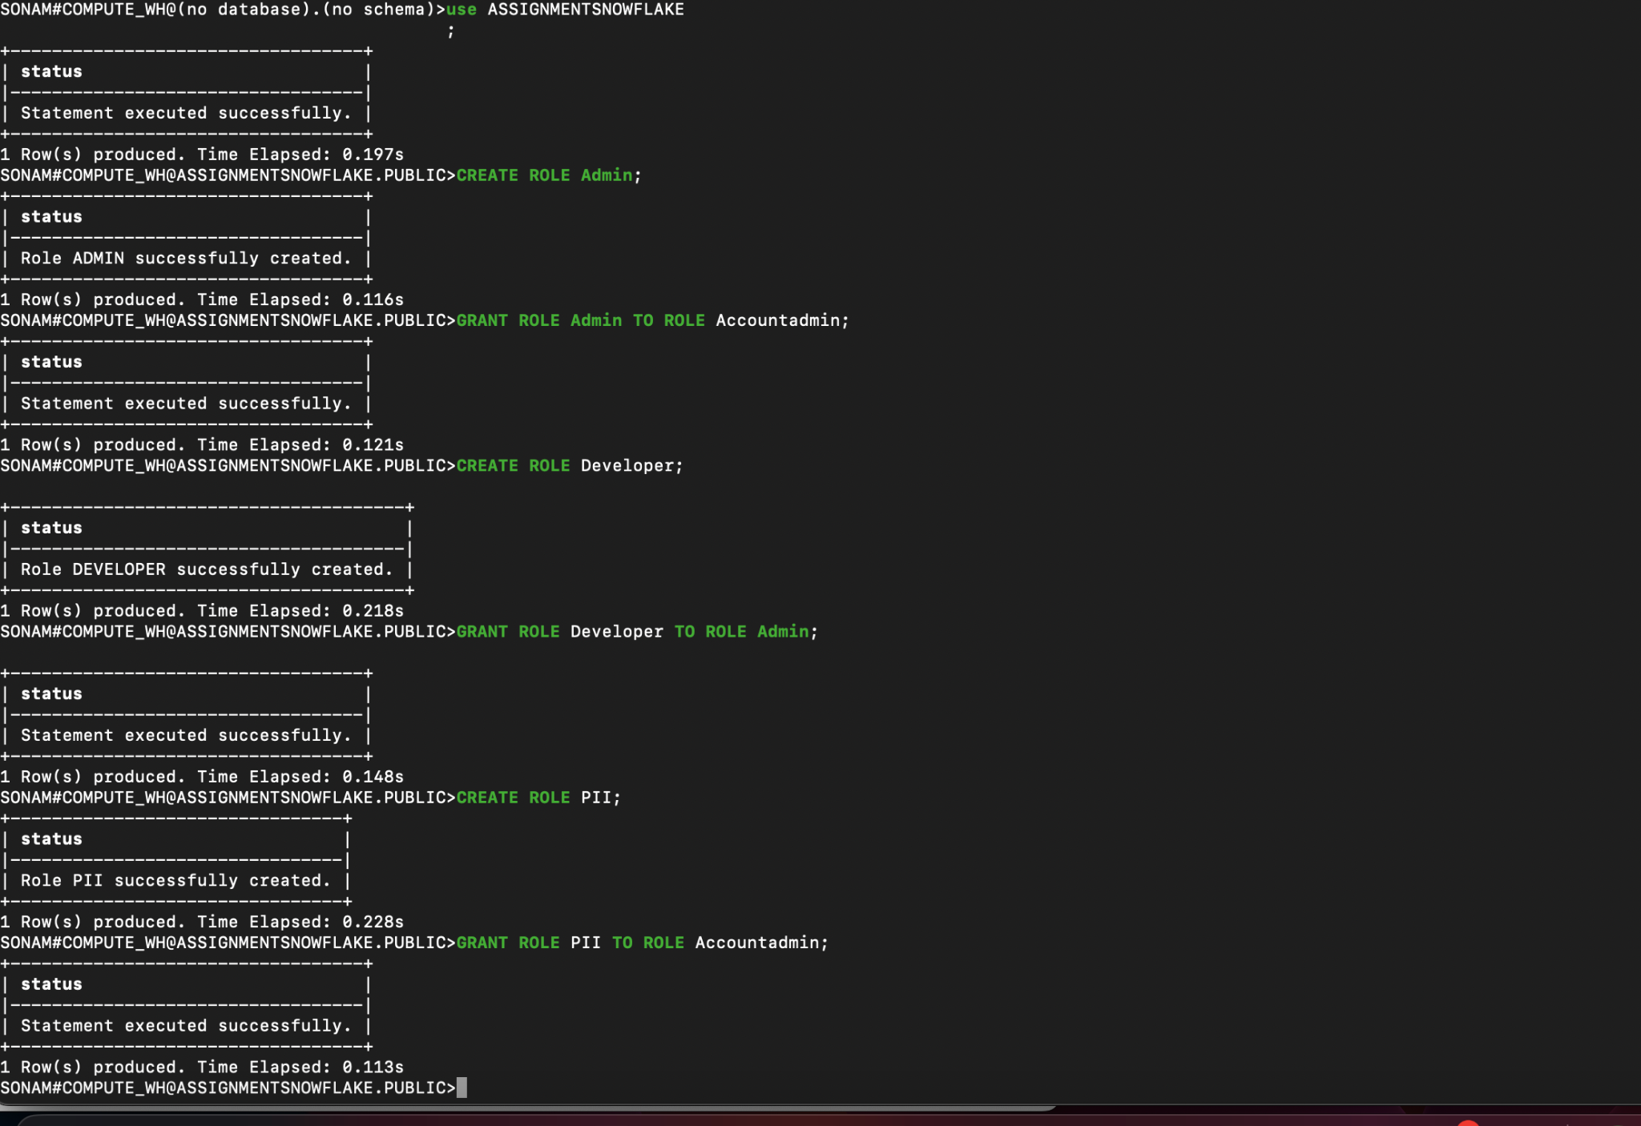

1. Create an M-sized warehouse using the accountadmin role, name -> assignment_wh and use it for all the queries

USE ROLE ACCOUNTADMIN;

CREATE WAREHOUSE IF NOT EXISTS ASSIGNMENT_WH

WITH WAREHOUSE_SIZE = 'MEDIUM';

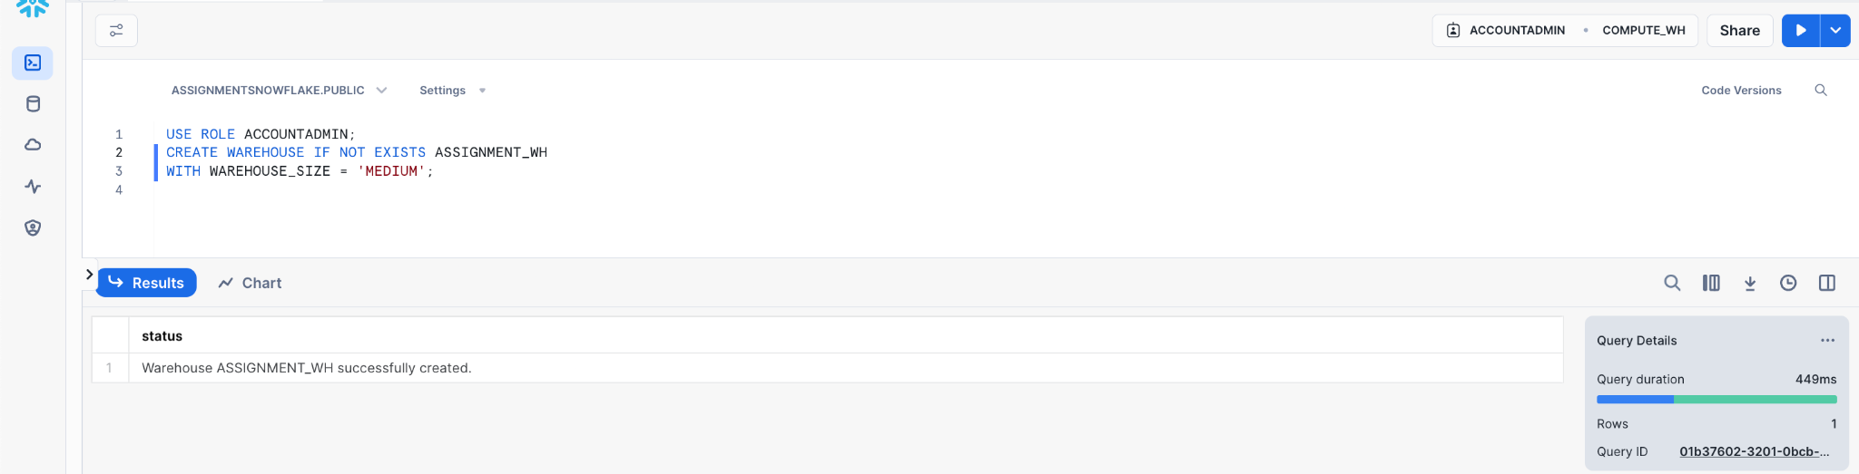

1. Switch to the admin role

**USE** **ROLE** **ADMIN**;

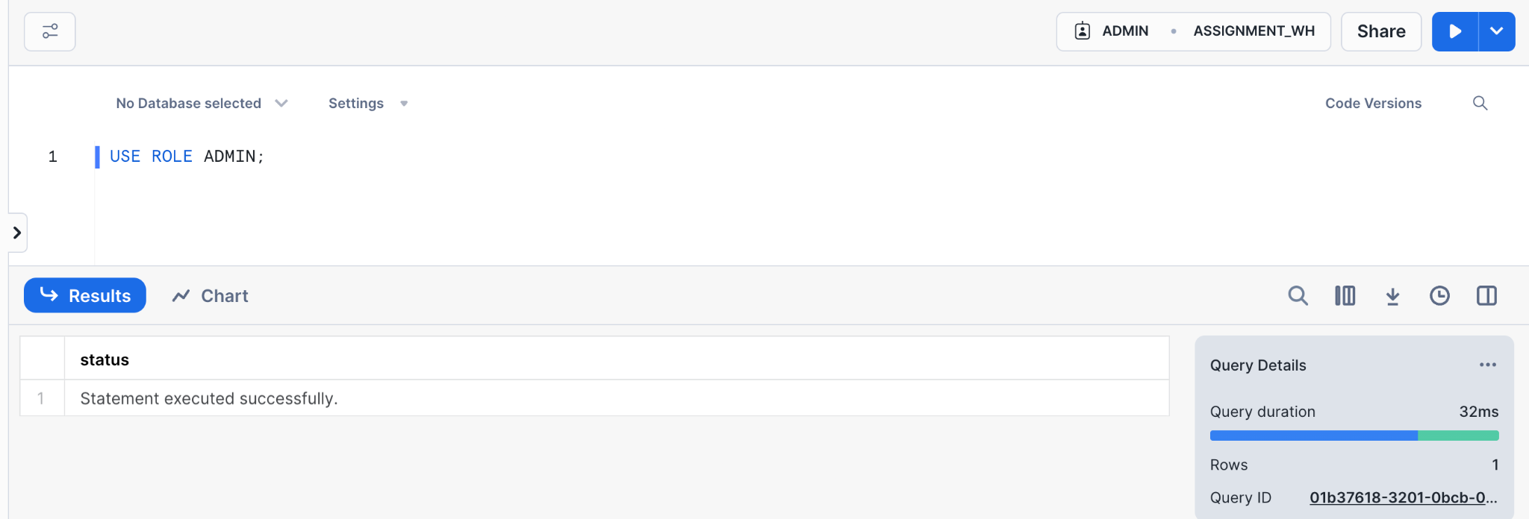

4) Create a database assignment_db

**CREATE** **DATABASE** ASSIGNMENT_DB;

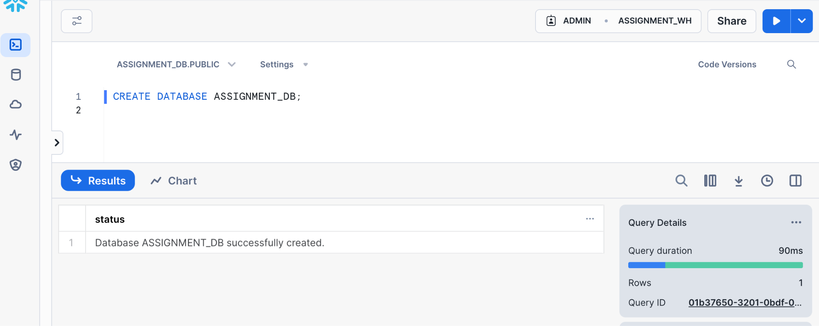

5) Create a schema my_schema

CREATE SCHEMA MY_SCHEMA;

USE SCHEMA MY_SCHEMA;

6) Create a table using any sample csv. You can get 1 by googling for sample csv’s. Preferably search for a sample employee dataset so that you have PII related columns else you can consider any column as PII ( 5 ).

CREATE TABLE employeeData1 (

Emp_ID INT,

Name_Prefix STRING,

First_Name STRING,

Middle_Initial STRING,

Last_Name STRING,

Gender STRING,

E_Mail STRING,

Fathers_Name STRING,

Mothers_Name STRING,

Mothers_Maiden_Name STRING,

Salary FLOAT,

elt_ts TIMESTAMP DEFAULT CURRENT_DATE,

elt_by VARCHAR(50) DEFAULT 'SnowSqL',

file_name VARCHAR(255)

);

7) Also, create a variant version of this dataset

CREATE OR REPLACE TABLE variant_employeeData (

Emp_ID INT,

Name_Details VARIANT,

Contact_Details VARIANT,

Family_Details VARIANT,

Salary FLOAT,

elt_ts TIMESTAMP DEFAULT CURRENT_TIMESTAMP,

elt_by VARCHAR(50) DEFAULT 'SnowSQL',

file_name VARCHAR(255)

);

– To Load data into variant table

– Creating a staging table

CREATE OR REPLACE TEMPORARY TABLE staging_employeeData (

Emp_ID INT,

Name_Prefix STRING,

First_Name STRING,

Middle_Initial STRING,

Last_Name STRING,

Gender STRING,

E_Mail STRING,

Fathers_Name STRING,

Mothers_Name STRING,

Mothers_Maiden_Name STRING,

Salary FLOAT

);

– Load data into the staging table

CREATE OR REPLACE STAGE staging_employeeData

FILE_FORMAT = my_csv_format;

**PUT** **file**:///**Users**/sonamkumari/Desktop/emp_dataset.csv @staging_employeeData;

COPY INTO staging_employeeData

FROM @staging_employeeData

FILE_FORMAT = (TYPE = 'CSV', SKIP_HEADER = 1)

ON_ERROR = 'CONTINUE';

– Transform and insert data into final table

INSERT INTO variant_employeeData (Emp_ID, Name_Details, Contact_Details, Family_Details, Salary, elt_by, file_name)

SELECT

Emp_ID,

OBJECT_CONSTRUCT(

'Name Prefix', Name_Prefix,

'First Name', First_Name,

'Middle Initial', Middle_Initial,

'Last Name', Last_Name,

'Gender', Gender

) AS Name_Details,

OBJECT_CONSTRUCT(

'E Mail', E_Mail

) AS Contact_Details,

OBJECT_CONSTRUCT(

'Father''s Name', Fathers_Name,

'Mother''s Name', Mothers_Name,

'Mother''s Maiden Name', Mothers_Maiden_Name

) AS Family_Details,

Salary,

'SnowSQL', -- Assuming the elt_by is hardcoded for this example

'variant_dataset.csv' -- Assuming a single source file for simplicity

FROM

staging_employeeData;

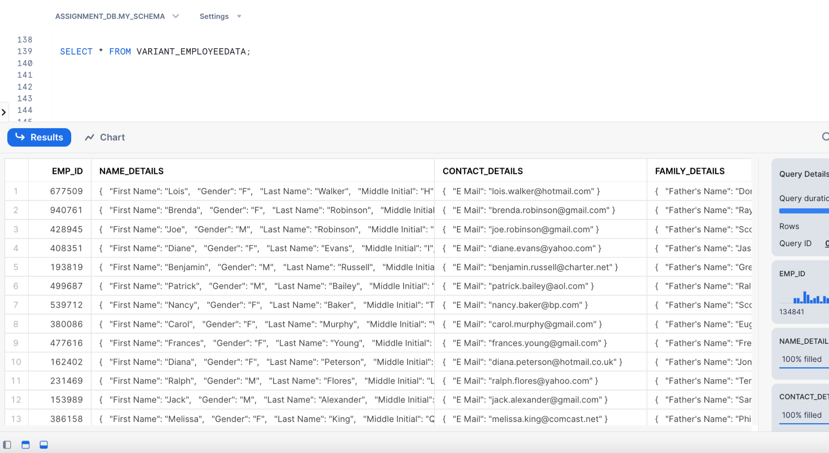

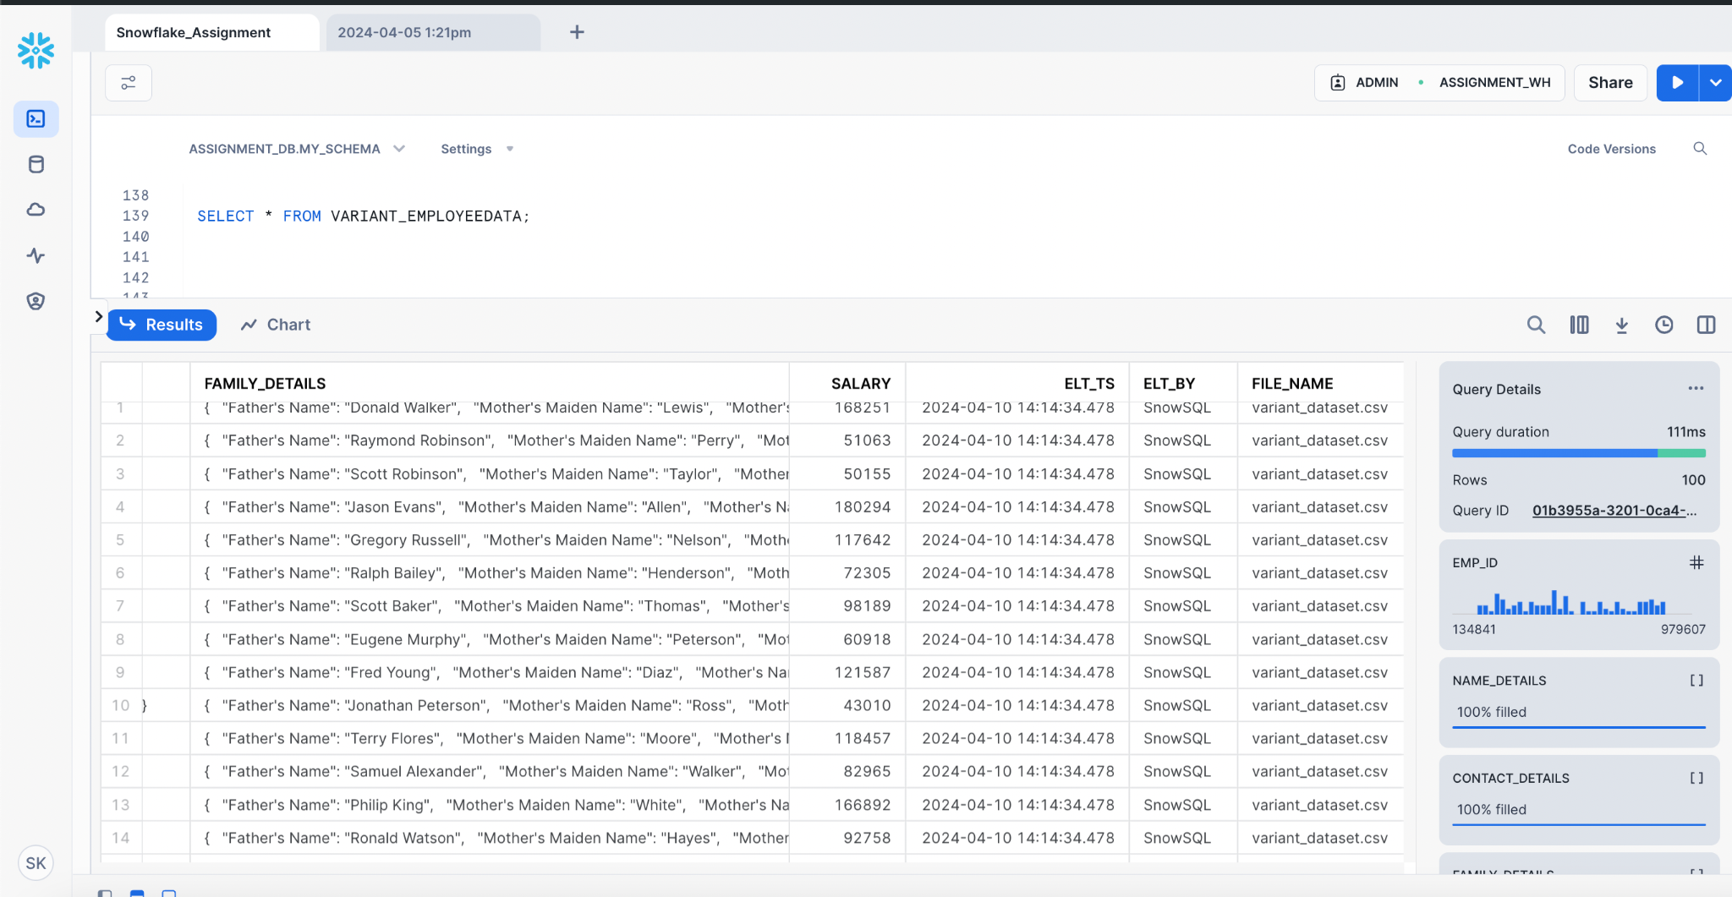

8) Load the file into an external and internal stage

AND

9) Load data into the tables using copy into statements. In one table load from the internal stage and in another from the external

*Internal Stage*

**CREATE** **OR** **REPLACE** **FILE** **FORMAT** my_csv_format

**TYPE** = 'CSV'

FIELD_DELIMITER = ','

SKIP_HEADER= 1;

**CREATE** **OR** **REPLACE** **STAGE** my_stage

FILE_FORMAT = my_csv_format;

**PUT** **file**:///**Users**/sonamkumari/Desktop/emp_dataset.csv @my_stage;

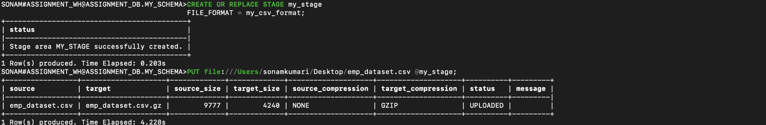

**COPY** **INTO** employeeData1 (

Emp_ID,

Name_Prefix,

First_Name,

Middle_Initial,

Last_Name,

Gender,

E_Mail,

Fathers_Name,

Mothers_Name,

Mothers_Maiden_Name,

Salary,

elt_ts,

elt_by,

file_name

)

**FROM** (

**SELECT**

$1, $2, $3, $4, $5, $6, $7, $8, $9, $10, $11,

**CURRENT_TIMESTAMP**,

'SnowSqL',

METADATA$FILENAME

**FROM**

@my_stage/emp_dataset.csv.gz

(file_format => my_csv_format) **t**

)

ON_ERROR = 'CONTINUE';

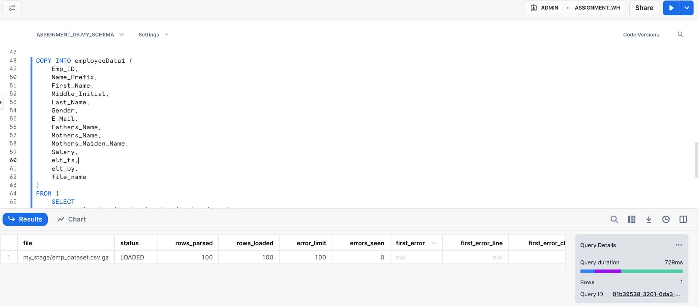

– Viewing the loaded data

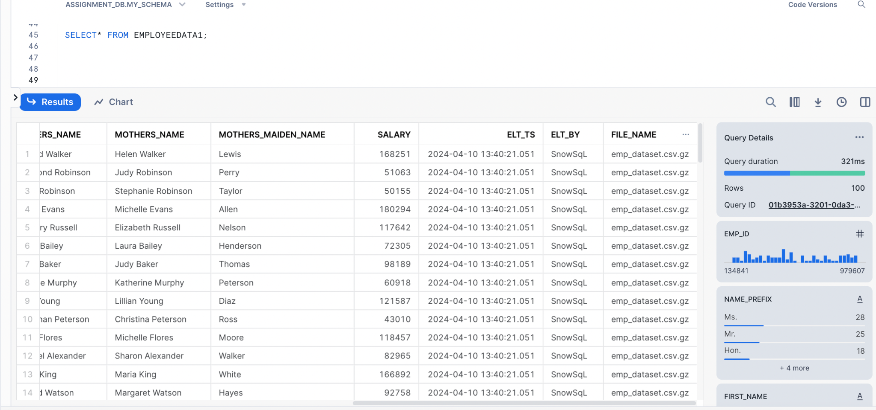

*External Staging:*

**USE** **SCHEMA** EXTERNAL_MY_SCHEMA;

**CREATE** **OR** **REPLACE** **FILE** **FORMAT** my_csv_format

**TYPE** = 'CSV'

FIELD_DELIMITER = ','

SKIP_HEADER= 1;

**create** **or** **replace** **stage** external_stage

url='azure://snowflakesonamassignment.blob.core.window

s.net/snowflakeassignmentcontainer/emp_dataset.csv'

**CREDENTIALS**=(

azure_sas_token='sv=2022-11-02&ss=bfqt&srt=sco&sp=rwdl

acupiytfx&se=2024-04-05T20:01:09Z&st=2024-04-05T12:01:

09Z&spr=https&sig=6ZGlk5Do8eioascWWAy8W%2FPRMFqj4Np58N

Syr%2FobhXY%3D'

)

File_format=my_csv_format;

**COPY** **INTO** employeeDataExternal (

Emp_ID,

Name_Prefix,

First_Name,

Middle_Initial,

Last_Name,

Gender,

E_Mail,

Fathers_Name,

Mothers_Name,

Mothers_Maiden_Name,

Salary,

elt_ts,

elt_by,

file_name

)

**FROM** (

**SELECT**

$1, $2, $3, $4, $5, $6, $7, $8, $9, $10, $11,

**CURRENT_TIMESTAMP**,

stamp

'SnowSqL',

METADATA$FILENAME

**FROM**

@external_stage/emp_dataset.csv.gz

(file_format => my_csv_format) **t**

)

ON_ERROR = 'CONTINUE';

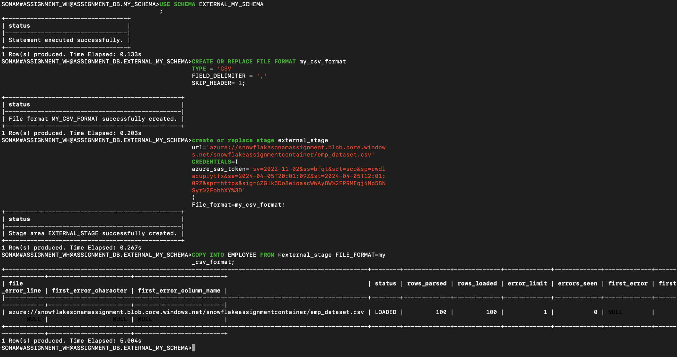

10) Upload any parquet file to the stage location and infer the schema of the file

**CREATE** **OR** **REPLACE** **FILE** **FORMAT** parquet_format **TYPE**=parquet;

**PUT** **file**:///**Users**/sonamkumari/Desktop/accountdevices.parquet @parquetstage;



11) Run a select query on the staged parquet file without loading it to a snowflake table

**SELECT** * **FROM** **TABLE**(

infer_schema( **location**=>'@myparquetstage/accountdevices.parquet',

file_format=>'parquet_format')

);

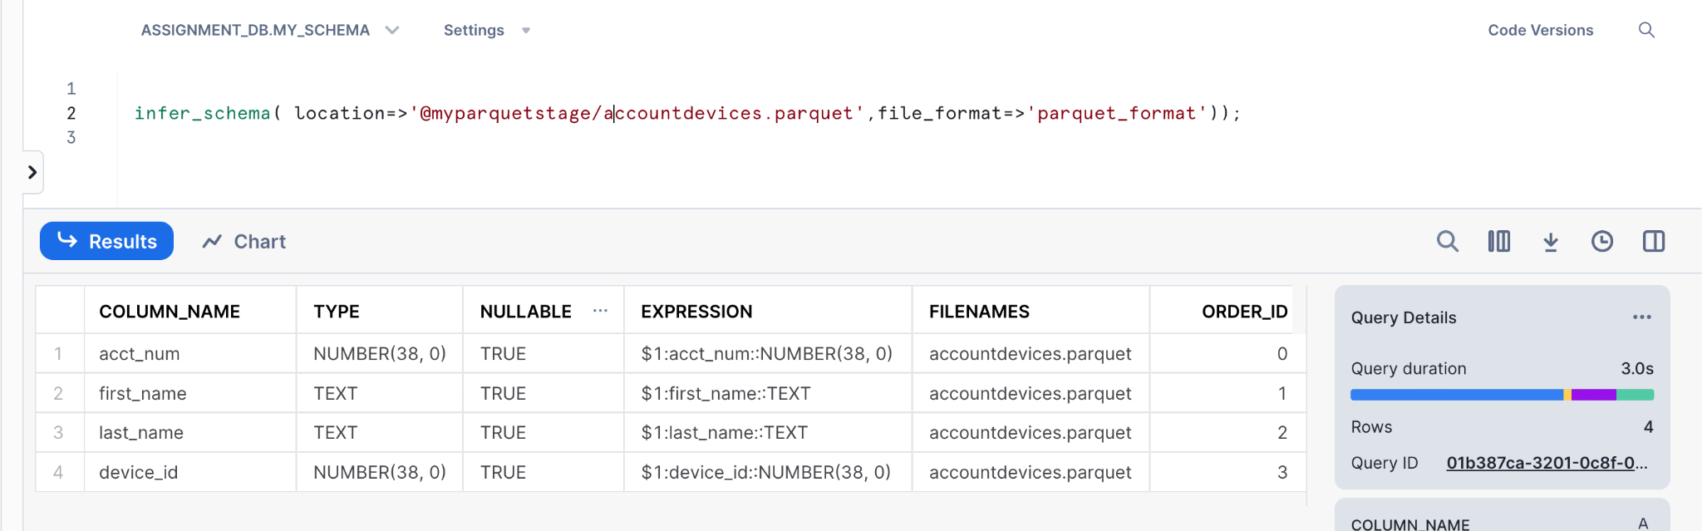

12) Add masking policy to the PII columns such that fields like email, phone number, etc. show as **masked** to a user with the developer role. If the role is PII the value of these columns should be visible

**CREATE** **OR** **REPLACE** **MASKING** **POLICY** pii_masking_policy **AS** (val STRING) **RETURNS** STRING ->

**CASE**

**WHEN** **CURRENT_ROLE**() **IN** ('PII') **THEN** val

**ELSE** '**masked**'

**END**;

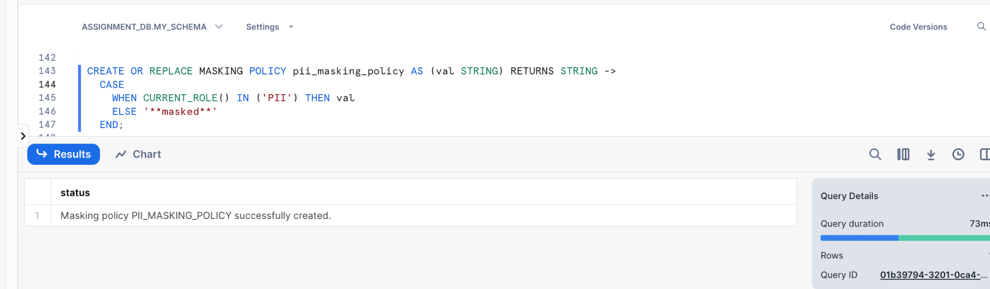

**ALTER** **TABLE** EMPLOYEEDATA

**MODIFY** **COLUMN** E_Mail **SET** **MASKING** **POLICY** pii_masking_policy;

**CREATE** **OR** **REPLACE** **MASKING** **POLICY** pii_masking_policy_for_salary **AS** (val FLOAT)

**RETURNS** FLOAT ->

**CASE**

**WHEN** **CURRENT_ROLE**() **IN** ('PII') **THEN** val

**ELSE** -1.0

**END**;

**ALTER** **TABLE** EMPLOYEEDATA **MODIFY** **COLUMN** SALARY **SET** **MASKING** **POLICY** pii_masking_policy_for_salary;

USE ROLE ACCOUNTADMIN;

GRANT USAGE ON DATABASE ASSIGNMENT_DB TO ROLE PII;

GRANT USAGE ON DATABASE ASSIGNMENT_DB TO ROLE DEVELOPER;

GRANT USAGE ON SCHEMA ASSIGNMENT_DB.MY_SCHEMA TO ROLE PII;

GRANT USAGE ON SCHEMA ASSIGNMENT_DB.MY_SCHEMA TO ROLE DEVELOPER;

GRANT SELECT ON ALL TABLES IN SCHEMA ASSIGNMENT_DB.MY_SCHEMA TO ROLE PII;

GRANT SELECT ON ALL TABLES IN SCHEMA ASSIGNMENT_DB.MY_SCHEMA TO ROLE DEVELOPER;

GRANT USAGE ON WAREHOUSE ASSIGNMENT_WH TO ROLE PII;

GRANT USAGE ON WAREHOUSE ASSIGNMENT_WH TO ROLE DEVELOPER;

USE ROLE PII;

SELECT * FROM ASSIGNMENT_DB.MY_SCHEMA.EMPLOYEEDATA;

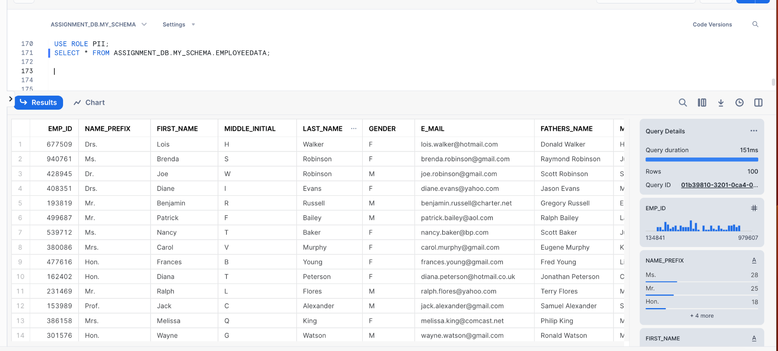

USE ROLE DEVELOPER;

SELECT * FROM ASSIGNMENT_DB.MY_SCHEMA.EMPLOYEEDATA;

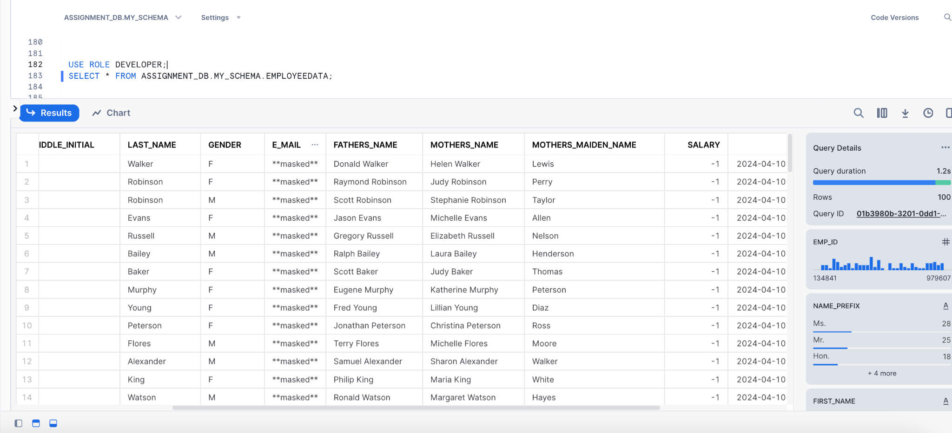

—-x—x—